**APPLECROSS SENIOR HIGH SCHOOL**

**YEAR 11 HUMAN BIOLOGY**

**TEST 3**

**DO NOT MARK THIS PAPER IS ANY WAY - USE THE ANSWER SHEET**

Time allowed: 50 minutes Total marks: 50

**PART A: Multiple Choice (20 marks)**

1. Besides excreting harmful and unwanted substances the kidneys also:

a) deaminate proteins.

b) transform glucose into the polymer glycogen.

c) regulate the fluid content of the blood.

d) manufacture urea.

2. Which of the following describes the pathway of a waste molecule which is excreted by the kidney?

a) Bowman’s capsule 🡪 glomerulus 🡪 tubule 🡪 ureter 🡪 bladder

b) glomerulus 🡪 Bowman’s capsule 🡪 tubule 🡪 urethra 🡪 bladder

c) Bowman’s capsule 🡪 glomerulus 🡪 tubule 🡪 urethra 🡪 bladder

d) glomerulus 🡪 Bowman’s capsule 🡪 tubule 🡪 ureter 🡪 bladder

3. Consider the concentration of water in blood of the artery supplying the kidney and in the blood of the vein leading from the kidney. Which of the following statements is correct?

a) The concentration of water in the blood of the artery supplying the kidney is greater than the concentration of water in the blood of the vein leading from the kidney.

b) The concentration of water in the blood of the artery supplying the kidney is less than the concentration of water in the blood of the vein leading from the kidney.

c) There is no significant difference between the concentration of water in blood of the artery supplying the kidney and in the blood of the vein leading from the kidney

d) It is difficult to measure the concentration of water in blood of the artery supplying the kidney and in the blood of the vein leading from the kidney.

1. The nitrogen bases adenine, guanine, thymine and cytosine spell out a chemical code. This code is important because:

(a) it produces nucleotides.

(b) it codes for amino acids.

(c) it codes for ATP.

(d) it is a gene, which gets mutated to produce more advanced forms of life

1. The diagram represents a model of DNA replication. The steps are numbered.



Which of the following is the correct order?

1. 1,2,3,4
2. 2,3,4,1
3. 2,4,3,1
4. 4,1,4,3

6. Which is true of a codon?

a) It consists of three nucleotides.

b) It may code for the same amino acid as another codon does.

c) It never codes for more than one amino acid.

d) It extends from one end of a tRNA molecule

7. Which does NOT represent a difference between RNA and DNA?

a) RNA is single stranded.

b) RNA contains the sugar ribose.

c) RNA substitutes thymine for uracil.

d) RNA utilizes nucleotides in its structure.

In question **8** below, a segment of DNA has one strand with the following sequence of bases.

**A G C G C A T A G C A A**

8 The complementary strand of DNA is

a) U C G C G U A U C G U U

b) T C G C C G A T C G T T

c) T C G C G T A T C G T T

d) T C G C A T T A C A U U

9 In a eukaryotic cell, transcription takes place _____.

a) on free ribosomes

b) in the rough endoplasmic reticulum

c) in the cytoplasm

d) in the nucleus

10 Which are arranged in the correct order by size, from largest to smallest?

a) chromosome - gene - nucleotide - codon

b) chromosome - gene - codon - nucleotide

c) codon - chromosome - gene - nucleotide

d) nucleotide - chromosome - gene - codon

11. Imagine an error occurring during DNA replication in a cell, so that where there is supposed to be a T in one of the genes there is instead a G. What effect will this probably have on the cell?

a) The amino acid sequence of one of its kinds of protein will be completely changed

b) Each of its kinds of protein will contain an incorrect amino acid

c) One of its kinds of protein might contain an incorrect amino acid

d) An amino acid will be missing from one of its kinds of protein

12. During the process of translation, ________ matches an mRNA codon with the proper amino acid.

a) DNA polymerase

b) transfer RNA

c) a ribosome

d) messenger RNA

13. What is transcription?

a) The modification of a strand of RNA prior to the manufacture of a protein.

b) The manufacture of a strand of RNA complementary to a strand of DNA.

c) The manufacture of a protein based on information carried by RNA.

d) The manufacture of two new DNA double helices that are identical to an old DNA double helix.

14. Nucleotides contain which of the following?

a) protein, chromosomes, genes.

b) Nitrogen base, sugar, phosphate.

c) Protein, carbohydrate, DNA.

d) Sugar, fat, coiled proteins.

15. Scientists need to ensure they have as large a sample size as possible in investigations as this

a) improves the validity of the experiment.

b) ensures it is a fair test.

c) makes their results reliable.

d) determines how accurate their data is.

16. A subject was required to exercise for a total of 15 minutes, 5 minutes each time at a different level of intensity. Their carbon dioxide output at each intensity was measured every minute. Neither temperature nor humidity were measured at the time. In this investigation,

a) exercise is the independent variable.

b) carbon dioxide output is the dependent variable.

c) temperature would have had a large effect on the results.

d) humidity was a controlled variable.

Use the model below to answer questions 17 and 18.

Translation of the genetic code occurs in the cytoplasm of a cell. The following diagram is one representation of translation.

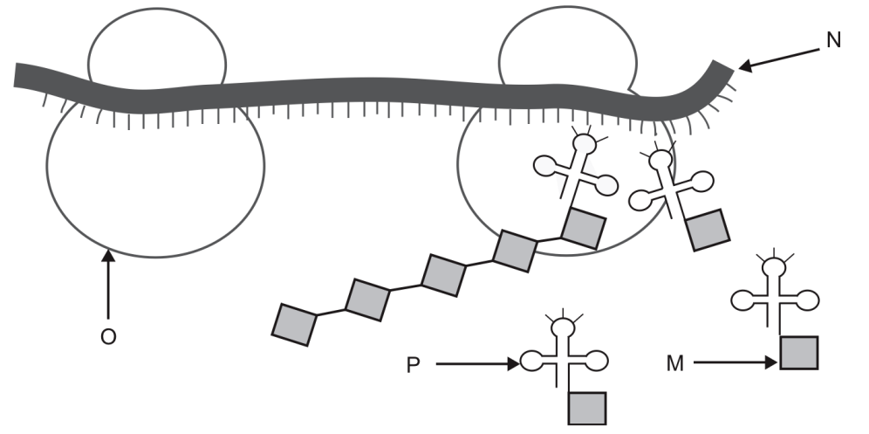

17. In the model presented

a) M represents a ribosome.

b) N represents messenger RNA.

c) O represents transfer RNA.

d) P represents an amino acid.

18. In the model presented

a) N represents a ribosome.

b) P represents messenger RNA.

c) O represents transfer RNA.

d) M represents an amino acid.

19 Oogenesis occurs in

a) an ovum.

b) the ovary.

c) the uterus.

d) a uterine tube.

20 A major difference between the production of gametes in males and females from the primary cell is that

a) in males its by mitosis and in females its by meosis

b) there are two nuclear divisions in males, only one in females

c) in females only one gamete is finally produced, in males there are four

d) males have motile gametes, while female gametes are non-motile.

**YEAR 11 HUMAN BIOLOGY TEST 3**

**PART B SHORT ANSWER SECTION**

**Name _________________________________________________ 30 MARKS**

**Complete each of the following questions in the spaces provided.**

21. There are four organs of the body which are involved in excretion of unwanted substances. Describe each of these by completing the following table. (8 marks)

|  |  |
| --- | --- |
| Excretory organ | Substances excreted |
|  |  |
|  |  |
|  |  |
|  |  |

22. The table below shows the relative concentrations of five substances in the primary filtrate and the urine of a person as a percentage of their concentration in the plasma.

|  |  |  |
| --- | --- | --- |
| Substance | Primary filtrate (%) | Urine (%) |
| Urea | 100 | 700 |
| Glucose | 100 | 0 |
| Amino Acid | 100 | 0 |
| Salt | 100 | 200 |
| Protein | 0 | 0 |

1. Use your understanding of kidney function to explain how each value is reached

Urea___________________________________________________________________

_____________________________________________________________________

Glucose_________________________________________________________________

_____________________________________________________________________

Amino Acid_____________________________________________________________

_____________________________________________________________________

Salt ____________________________________________________________________

_______________________________________________________________________

Protein _________________________________________________________________

_______________________________________________________________________

(5 marks)

b) A person was admitted to hospital with blood and other proteins in the urine. Suggest what structures in the nephron may have been damaged. Give a reason why.

___________________________________________________________________________

__________________________________________________________________________

___________________________________________________________________(2 marks)

23. Match the term on the left with its definition on the right. Use the letter of the correct definition (5 marks)

TERM DEFINITION

Replication ( ) A the changes in genes not caused by DNA

DNA ( ) B a sequence of three bases on a a mRNA molecule

RNA ( ) C a single stranded molecule found outside the nucleus

polymerase

Synthesis ( ) D the process by which small molecules join to make larger ones

Anticodon ( ) E coiled DNA and its proteins

RNA ( ) F a sequence of three bases found on a tRNA molecule

Codon ( ) G a double stranded molecule found in the nucleus

Epigenetics ( ) H the process by which DNA forms a replica of itself

Chromatin ( ) I the enzyme responsible for transcribing DNA to RNA

J the process of copying information to form proteins

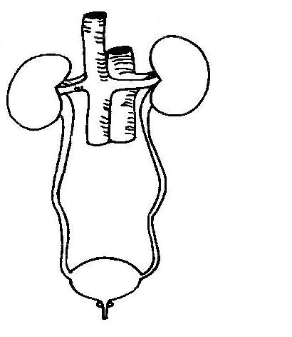24. Refer to this diagram

**X**

**W**

**X**

**Y**

(i) What body system does the diagram represent?

__________________________________________________

(ii) Provide the names of the parts labelled:

W __________________________ Y____________________________________

X __________________________ Z____________________________________ (5 marks)

25. Sperm and eggs (ova) are very different in appearance and function. Compare their structures and functions. ( 5 marks)

___________________________________________________________________________

___________________________________________________________________________

___________________________________________________________________________

___________________________________________________________________________

___________________________________________________________________________

___________________________________________________________________________

___________________________________________________________________________

___________________________________________________________________________

___________________________________________________________________________

___________________________________________________________________________